Lab Report

Your Information
Your Name: Joshua Zimmerman-Gibson
Assignment Title: Storing and Analyzing Data Using Amazon Redshift

Screenshots
Cluster Created
Created a single-node Redshift cluster
Endpoint: redshift-cluster-1.cwsl0o4xez7q.us-west-2.redshift.amazonaws.com:5439/caredshiftlab
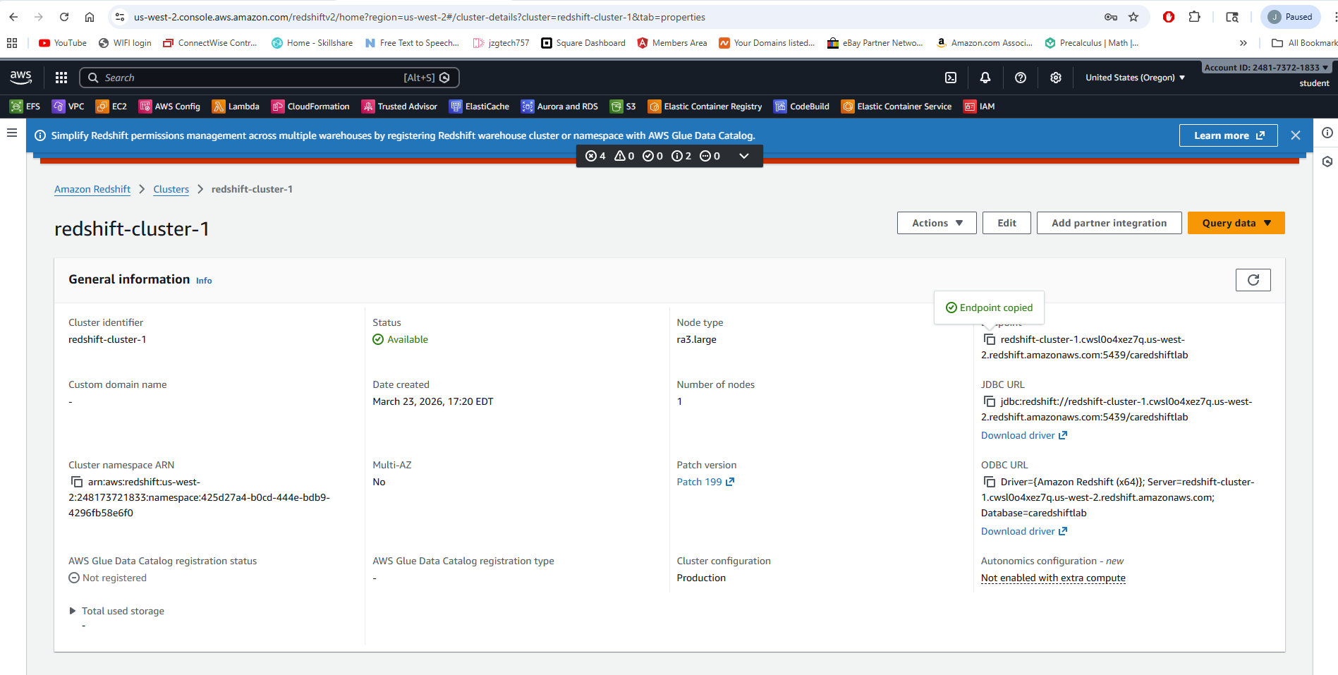
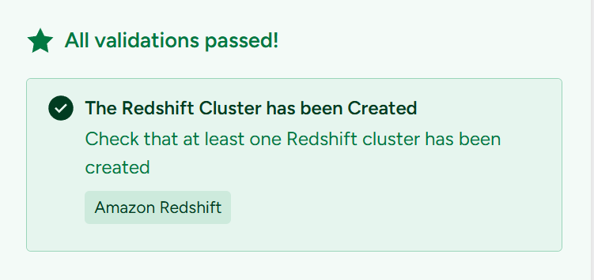
Connected to EC2 Instance
Connected to an EC2 Instance and opened a command shell.
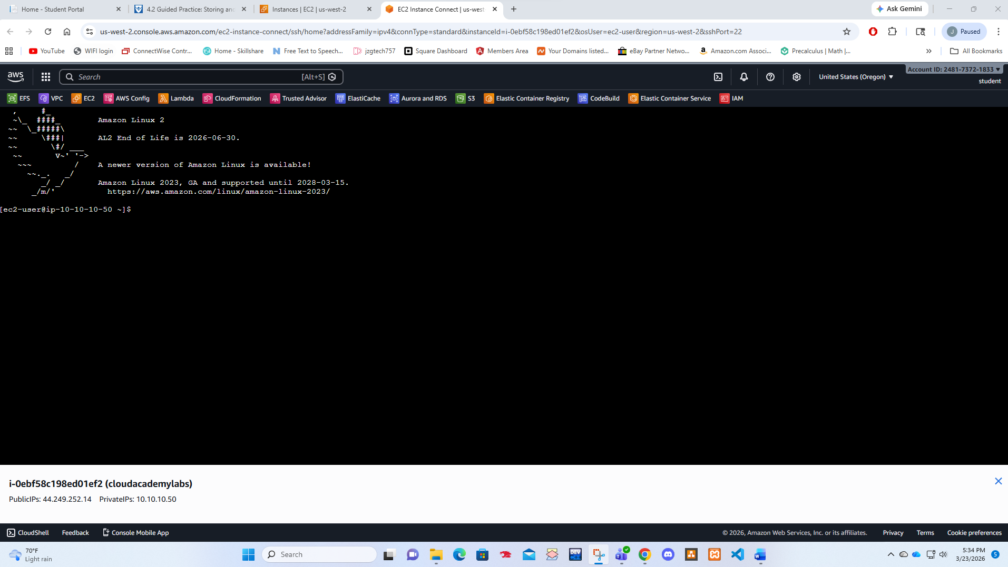
Loaded Data into Redshift
Utilized shell commands on an EC2 instance to copy data from Amazon Simple Storage Service (S3) buckets and load it into a Redshift cluster.
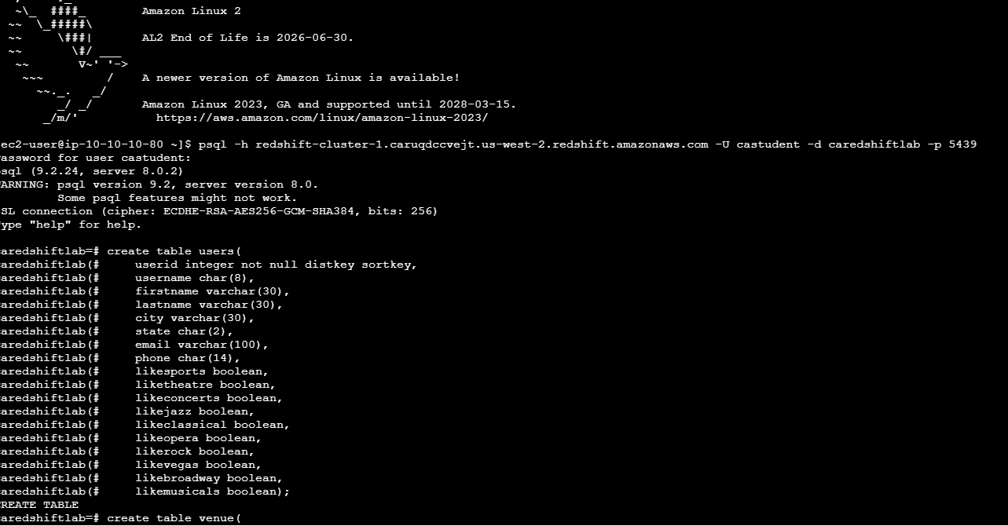
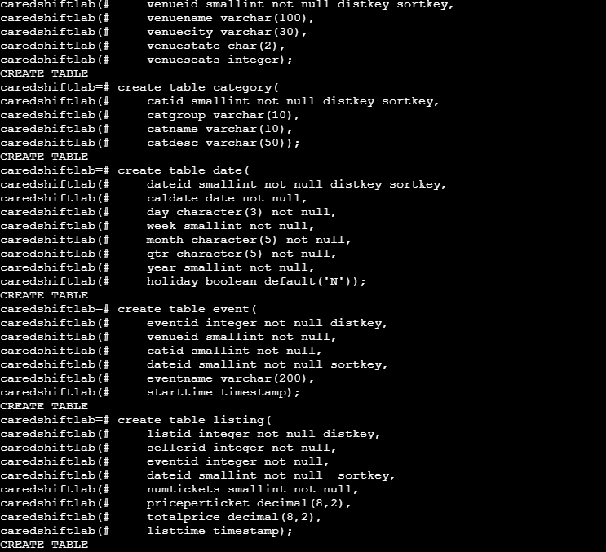
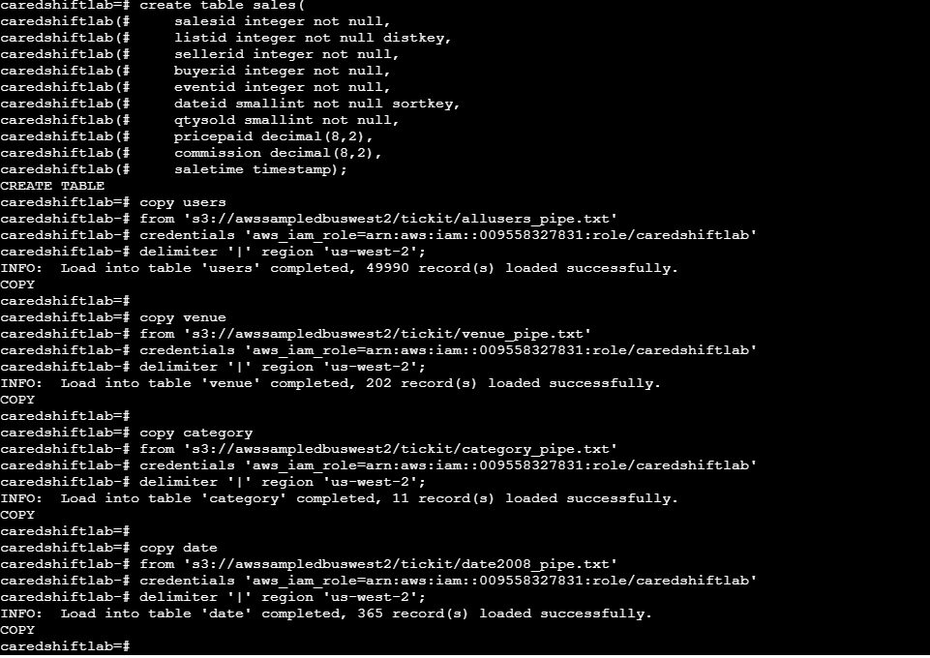
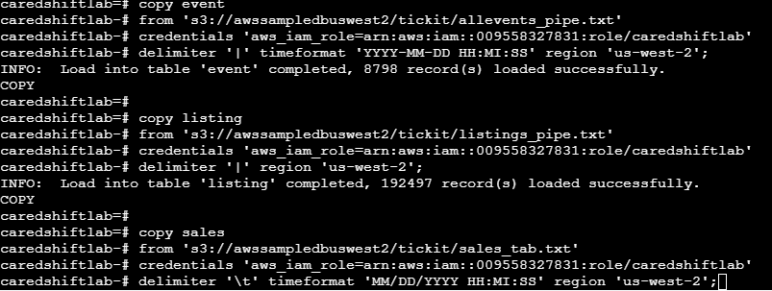
Performed SQL Queries on RedShift Cluster
Ran SQL queries on a single-node Redshift cluster and reviewed cluster performance metrics.
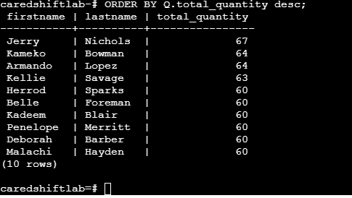
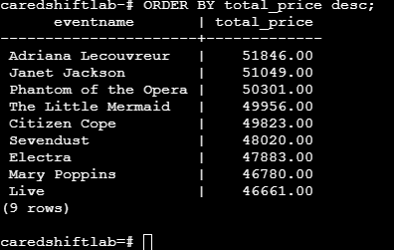
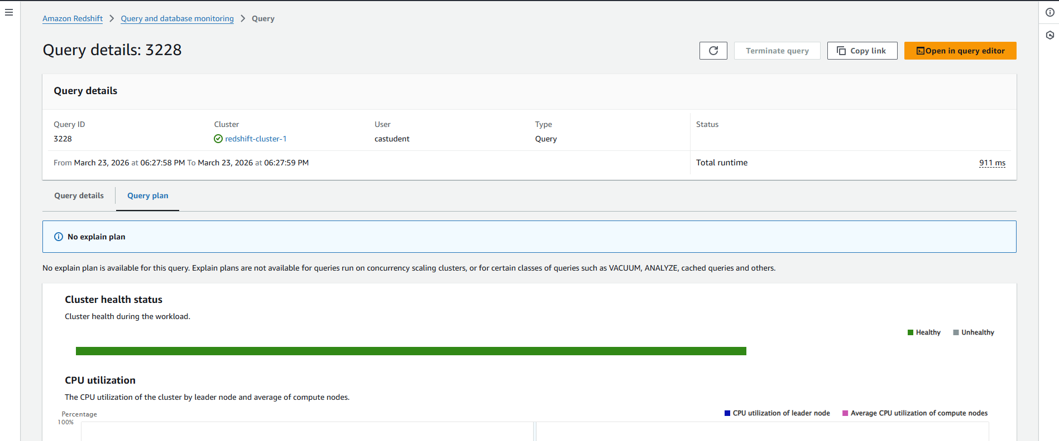
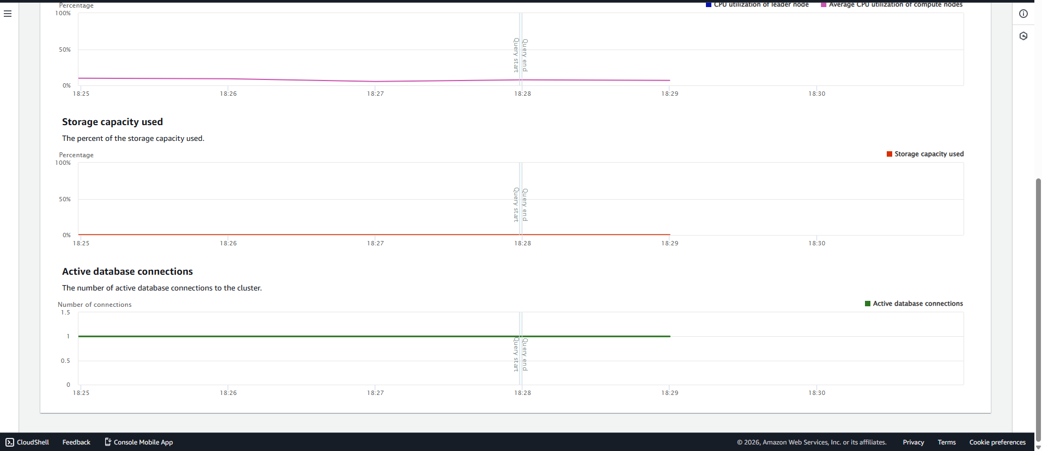
Resized the Cluster
Resized the Redshift cluster from single-node to multi-node.
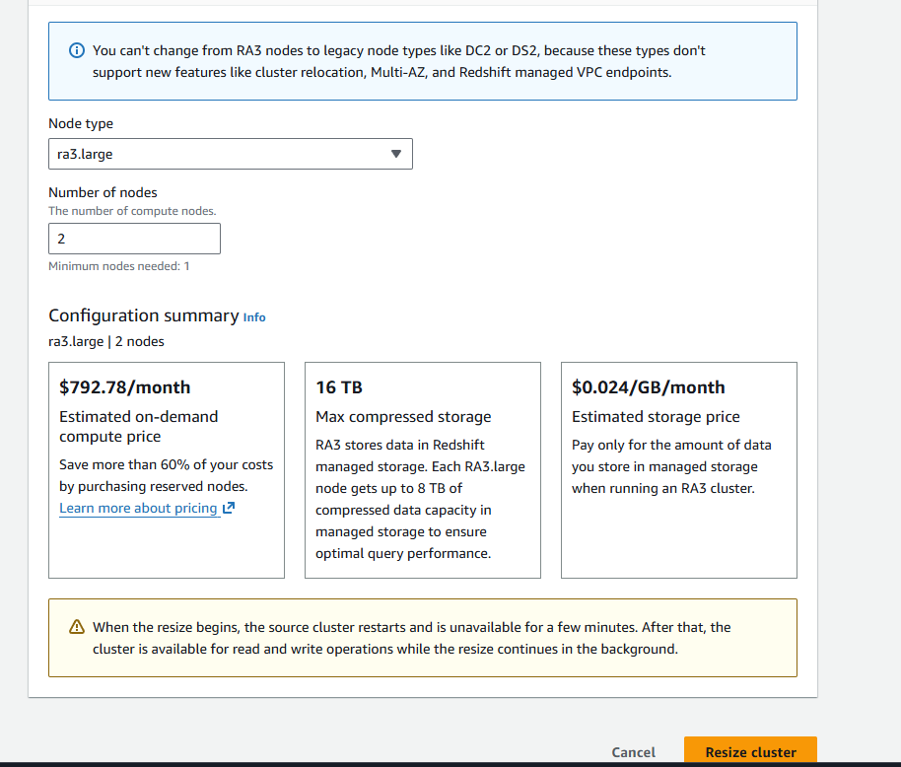
Deleted the Cluster
The Redshift cluster was deleted.
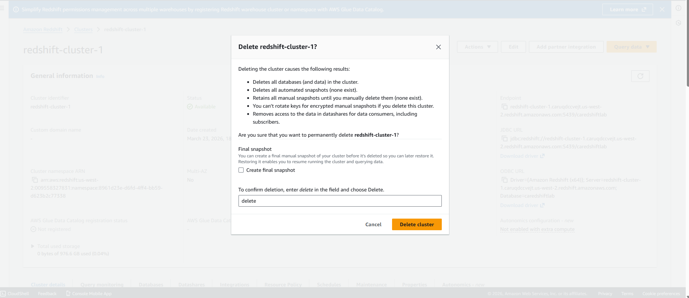
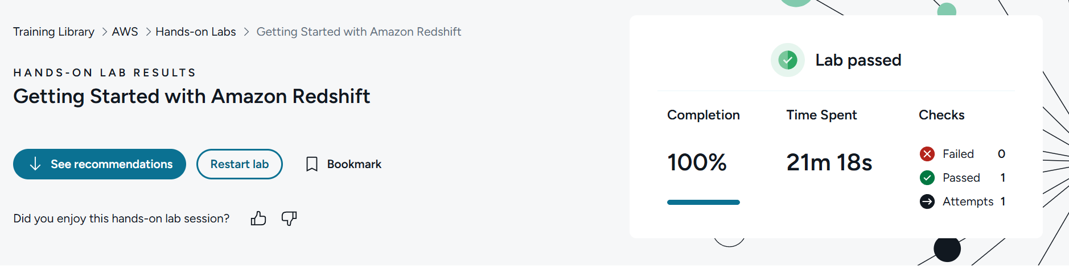

Questions
- What is an IAM role?
An IAM (Identity and Access Management) role in AWS is a set of permissions that define what actions an entity can perform within an AWS account. Unlike IAM users, roles do not have long-term credentials. Instead, they are assumed by users, applications, or AWS services that need temporary access.
IAM roles help securely delegate access to resources without sharing passwords or access keys.

- What kinds of storage mechanisms are used in S3 buckets versus Redshift clusters? Explain the differences between the two storage systems.
Amazon S3 (Simple Storage Service):
- Object storage service
- Stores data as objects (files + metadata) in buckets
- Designed for durability, scalability, and low-cost data storage
- Ideal for backups, images, logs, big data files, and static content
- Not optimized for complex querying or analytics on its own
Amazon Redshift:
- Fully managed data warehouse
- Uses columnar storage (data stored by column instead of by row)
- Optimized for SQL queries, analytics, and large-scale data processing
- Includes compression, parallel processing, and query optimization features
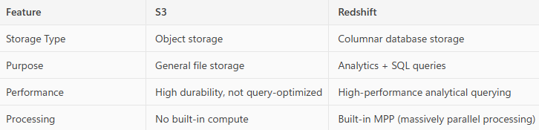
In short, S3 stores raw data, while Redshift stores structured data optimized for fast analysis.

- Why is it important to terminate EC2 instances (or other AWS services) when they are not in use?

It’s important to terminate unused EC2 instances and other AWS resources because:
- They continue to incur charges as long as they are running.
- Unused services waste budget and can cause unexpectedly high bills.
- Security risks increase if idle instances remain accessible on the network.
- Resource efficiency improves when unneeded compute resources are removed.
Terminating unused resources is a key practice in cost management, security, and cloud resource optimization.

